LAB MANUAL ON TIVA MICROCONTROLLER

BY: - VISHWANATH LAXMAN JOSHI
COMPANY NAME: - EDGATE TECHNOLOGY PVT. LTD.

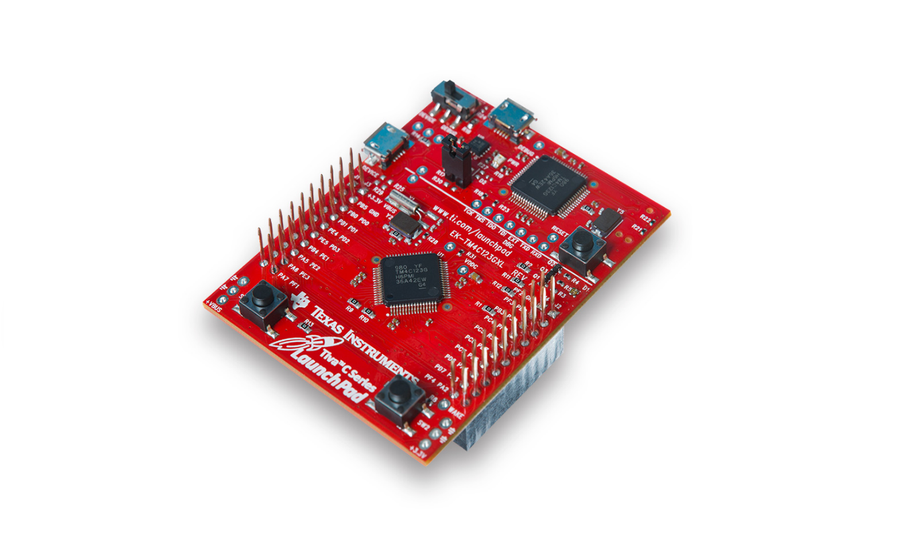

Experiment No 1
AIM: - To interface on board LED
Requirements: -
- Tiva microcontroller
- USB cable
- Code composer studio
- LED
- Tiva pinout diagram
Diagram: -
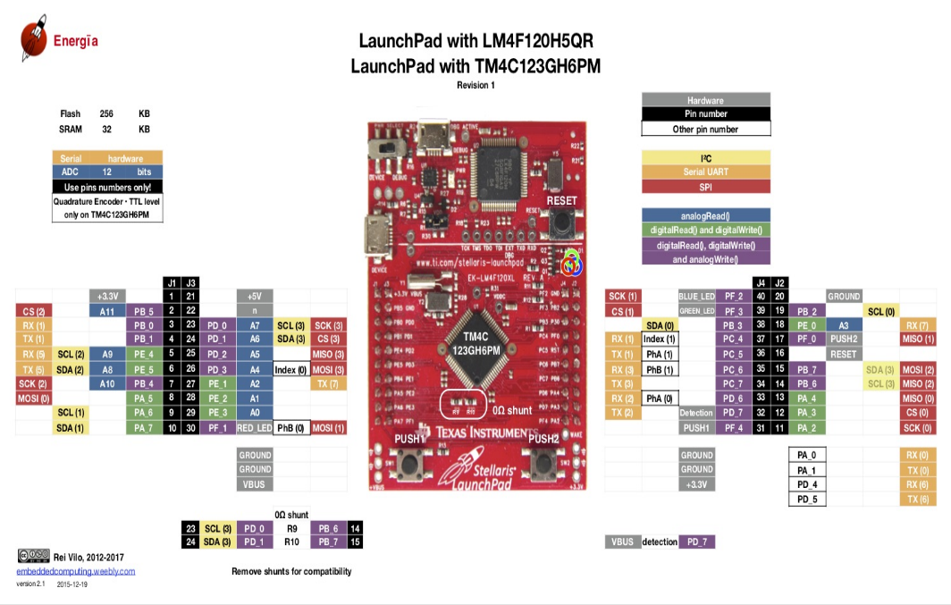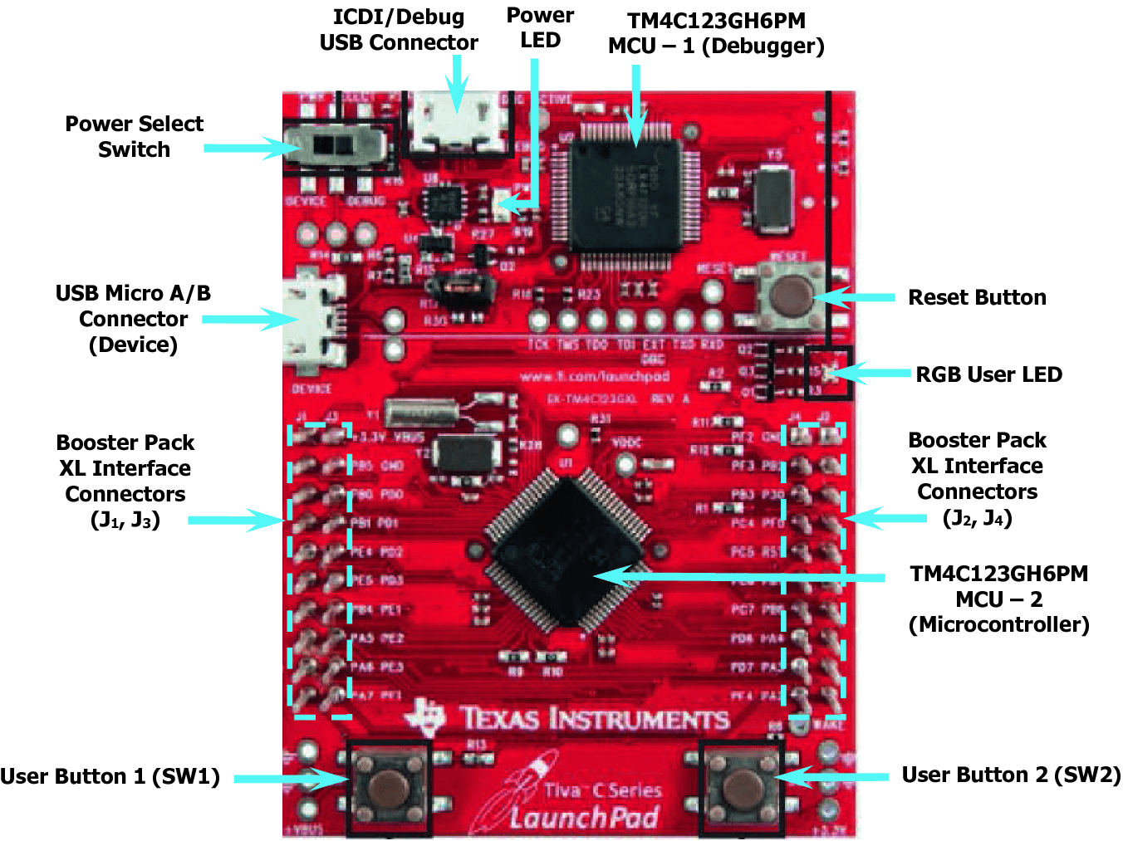
Code: -
/**
* main.c
*/
#include<stdint.h>
#include<stdbool.h>
#include<inc/tm4c123gh6pm.h>
#include<inc/hw_memmap.h>
#include<driverlib/gpio.h>
#include<driverlib/sysctl.h>

int main(void)
{
SysCtlClockSet(SYSCTL_SYSDIV_5|SYSCTL_XTAL_16MHZ| SYSCTL_OSC_MAIN| SYSCTL_USE_PLL);
SysCtlPeripheralEnable(SYSCTL_PERIPH_GPIOF);
GPIOPinTypeGPIOOutput(GPIO_PORTF_BASE , GPIO_PIN_1);
while(1)
{
GPIOPinWrite(GPIO_PORTF_BASE, GPIO_PIN_1, 0x02);
SysCtlDelay(13333333);
GPIOPinWrite(GPIO_PORTF_BASE, GPIO_PIN_1, 0x00);
SysCtlDelay(13333333);
}

}

Experiment No 2
AIM: - To interface on board LED and switch
Requirements: -
- Tiva microcontroller
- USB cable
- Code composer studio
- LED and Switch
- Tiva pinout diagram
Diagram: -
Code: -
#include<stdint.h>
#include<stdbool.h>
#include<inc/tm4c123gh6pm.h>
#include<inc/hw_memmap.h>
#include<driverlib/gpio.h>
#include<driverlib/sysctl.h>
int main(void)
{

SysCtlClockSet(SYSCTL_SYSDIV_5|SYSCTL_XTAL_16MHZ| SYSCTL_OSC_MAIN| SYSCTL_USE_PLL);
SysCtlPeripheralEnable(SYSCTL_PERIPH_GPIOF);
GPIOPinTypeGPIOOutput(GPIO_PORTF_BASE , GPIO_PIN_2);
GPIOPinTypeGPIOInput(GPIO_PORTF_BASE , GPIO_PIN_4);
GPIOPadConfigSet(GPIO_PORTF_BASE,GPIO_PIN_4,GPIO_STRENGTH_4MA,GPIO_PIN_TYPE_STD_WPU);
while(1){

if (GPIOPinRead(GPIO_PORTF_BASE , GPIO_PIN_4)==0){
GPIOPinWrite(GPIO_PORTF_BASE, GPIO_PIN_2, 0x04);
}
else{
GPIOPinWrite(GPIO_PORTF_BASE, GPIO_PIN_2, 0x00);
}

}
}
Experiment No 3
AIM: - To Enable Interrupt
Requirements: -
- Tiva microcontroller
- USB cable
- Code composer studio
- LED
- Tiva pinout diagram
Diagram: -
Code: -
#include<stdint.h>
#include<stdbool.h>
#include<inc/tm4c123gh6pm.h>
#include<inc/hw_memmap.h>
#include<driverlib/gpio.h>
#include<driverlib/sysctl.h>
#include<driverlib/interrupt.h>
int main(void)
{
int a;
SysCtlClockSet(SYSCTL_SYSDIV_5|SYSCTL_XTAL_16MHZ| SYSCTL_OSC_MAIN| SYSCTL_USE_PLL);
SysCtlPeripheralEnable(SYSCTL_PERIPH_GPIOF);
GPIOPinTypeGPIOOutput(GPIO_PORTF_BASE , GPIO_PIN_2);
GPIOPinTypeGPIOInput(GPIO_PORTF_BASE , GPIO_PIN_4);
GPIOPadConfigSet(GPIO_PORTF_BASE,GPIO_PIN_4,GPIO_STRENGTH_4MA,GPIO_PIN_TYPE_STD_WPU);
IntEnable(INT_GPIOF);
GPIOIntEnable(GPIO_PORTF_BASE, GPIO_PIN_4);
while(1)
{

}
}

void ISR_switch()
{
GPIOPinWrite(GPIO_PORTF_BASE, GPIO_PIN_2, 0x04);
SysCtlDelay((1*40000000)/3);
GPIOPinWrite(GPIO_PORTF_BASE, GPIO_PIN_2, 0x00);
SysCtlDelay((1*40000000)/3);
GPIOIntClear(GPIO_PORTF_BASE, GPIO_INT_PIN_4);

}

Experiment No 4
AIM: - To do traffic light controller using timers
Requirements: -
- Tiva microcontroller
- USB cable
- Code composer studio
- LED
- Tiva pinout diagram
Diagram: -
Code: -
#include<stdint.h>
#include<stdbool.h>
#include<inc/tm4c123gh6pm.h>
#include<inc/hw_memmap.h>
#include<driverlib/gpio.h>
#include<driverlib/sysctl.h>
#include<driverlib/timer.h>
#include<driverlib/interrupt.h>
int a,b=0;

int main(void)
{

SysCtlClockSet(SYSCTL_SYSDIV_8|SYSCTL_XTAL_16MHZ|SYSCTL_OSC_MAIN|SYSCTL_USE_PLL);
SysCtlPeripheralEnable(SYSCTL_PERIPH_GPIOF);

SysCtlPeripheralEnable(SYSCTL_PERIPH_TIMER0);
GPIOPinTypeGPIOOutput(GPIO_PORTF_BASE,GPIO_PIN_1|GPIO_PIN_3);
TimerConfigure(TIMER0_BASE,TIMER_CFG_PERIODIC);
TimerEnable(TIMER0_BASE,TIMER_A);

a=SysCtlClockGet();
GPIOPinWrite(GPIO_PORTF_BASE, GPIO_PIN_1, 0x02);

TimerLoadSet(TIMER0_BASE,TIMER_A,a);
IntEnable(INT_TIMER0A);
TimerIntEnable(TIMER0_BASE,TIMER_TIMA_TIMEOUT);

while(1){

}
}

void ISR_timer()
{
b+=a;
if(a*10==b){
GPIOPinWrite(GPIO_PORTF_BASE, GPIO_PIN_1|GPIO_PIN_3, 0x0A);

}
else if(a*15==b){
GPIOPinWrite(GPIO_PORTF_BASE, GPIO_PIN_1|GPIO_PIN_3, 0x00);
GPIOPinWrite(GPIO_PORTF_BASE, GPIO_PIN_3, 0x08);
}
else if(a*25==b){
GPIOPinWrite(GPIO_PORTF_BASE, GPIO_PIN_3, 0x00);

}
TimerIntClear(TIMER0_BASE,TIMER_TIMA_TIMEOUT);
}

Experiment No 5
AIM: - To control led using PWM peripheral
Requirements: -
- Tiva microcontroller
- USB cable
- Code composer studio
- LED
- Tiva pinout diagram
Diagram: -
Code: -
#include<stdint.h>
#include<stdbool.h>
#include<inc/tm4c123gh6pm.h>
#include<inc/hw_memmap.h>
#include<driverlib/gpio.h>
#include<driverlib/sysctl.h>
#include<driverlib/pwm.h>
#include<driverlib/pin_map.h>
int main(void)
{
int i;
SysCtlClockSet(SYSCTL_SYSDIV_5|SYSCTL_XTAL_16MHZ|SYSCTL_OSC_MAIN|SYSCTL_USE_PLL);
SysCtlPWMClockSet(SYSCTL_PWMDIV_16);
SysCtlPeripheralEnable(SYSCTL_PERIPH_PWM1);
SysCtlPeripheralEnable(SYSCTL_PERIPH_GPIOD);
GPIOPinTypePWM(GPIO_PORTD_BASE,GPIO_PIN_0);
GPIOPinConfigure(GPIO_PD0_M1PWM0);
PWMGenConfigure(PWM1_BASE, PWM_GEN_0, PWM_GEN_MODE_DOWN);
PWMGenPeriodSet(PWM1_BASE, PWM_GEN_0,100);
PWMOutputState(PWM1_BASE, PWM_OUT_0_BIT, true);
PWMGenEnable(PWM1_BASE, PWM_GEN_0);
while(1){
for(i=0;i<=150;i+=10){
PWMPulseWidthSet(PWM1_BASE,PWM_OUT_0,i);
SysCtlDelay(133333333);
}}}
Experiment No 6
AIM: - To convert analog values to digital values using ADC peripheral
Requirements: -
- Tiva microcontroller
- USB cable
- Code composer studio
- POT
- Tiva pinout diagram
Diagram: -
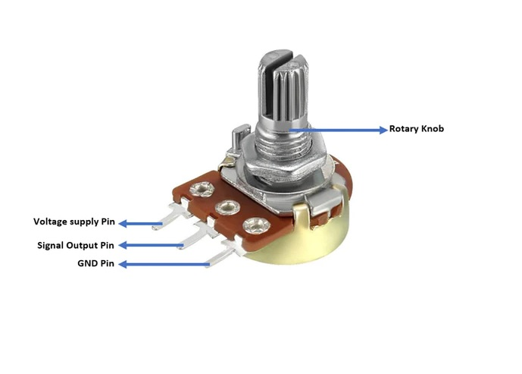

Code: -
#include<stdint.h>
#include<stdbool.h>
#include<inc/tm4c123gh6pm.h>
#include<inc/hw_memmap.h>
#include<driverlib/gpio.h>
#include<driverlib/sysctl.h>
#include<driverlib/adc.h>

int main(void)
{
uint32_t A[1];
SysCtlClockSet(SYSCTL_SYSDIV_5|SYSCTL_XTAL_16MHZ|SYSCTL_OSC_MAIN|SYSCTL_USE_PLL);
SysCtlPeripheralEnable(SYSCTL_PERIPH_ADC0);
SysCtlPeripheralEnable(SYSCTL_PERIPH_GPIOE);
GPIOPinTypeADC(GPIO_PORTE_BASE,GPIO_PIN_1);
ADCSequenceConfigure(ADC0_BASE,1,ADC_TRIGGER_PROCESSOR,0);
ADCSequenceStepConfigure(ADC0_BASE,1,0,ADC_CTL_CH2);
ADCSequenceEnable(ADC0_BASE,1);
while(1){
ADCProcessorTrigger(ADC0_BASE,1);
ADCSequenceDataGet(ADC0_BASE,1, A);
SysCtlDelay(13333333);
}
}

Experiment No 7
AIM: - To establish UART communication protocol between two devices
Requirements: -
- Tiva microcontroller
- USB cable
- Code composer studio
- Tiva pinout diagram
Diagram: -
Code: -
#include<stdint.h>
#include<stdbool.h>
#include<inc/tm4c123gh6pm.h>
#include<inc/hw_memmap.h>
#include<driverlib/gpio.h>
#include<driverlib/sysctl.h>
#include<driverlib/uart.h>
#include<driverlib/pin_map.h>
#include<utils/uartstdio.h>
#include<utils/uartstdio.c>

#include<string.h>
int main(void)
{
// char ch[]="Vishwanath";
SysCtlClockSet(SYSCTL_SYSDIV_5|SYSCTL_XTAL_16MHZ|SYSCTL_OSC_MAIN|SYSCTL_USE_PLL);
SysCtlPeripheralEnable(SYSCTL_PERIPH_UART0);
SysCtlPeripheralEnable(SYSCTL_PERIPH_GPIOA);
GPIOPinConfigure(GPIO_PA0_U0RX);
GPIOPinConfigure(GPIO_PA1_U0TX);
GPIOPinTypeUART(GPIO_PORTA_BASE,GPIO_PIN_0|GPIO_PIN_1);
UARTClockSourceSet(UART0_BASE,SysCtlClockGet());
UARTStdioConfig(0, 9600,SysCtlClockGet());
// UARTConfigSetExpClk(UART0_BASE,SysCtlClockGet(),9600,UART_CONFIG_WLEN_8|UART_CONFIG_STOP_ONE|UART_CONFIG_PAR_NONE);
while(1){

UARTCharPut(UART0_BASE,'v');
UARTCharPut(UART0_BASE,'i');
UARTCharPut(UART0_BASE,'s');
UARTCharPut(UART0_BASE,'h');
UARTCharPut(UART0_BASE,'w');
UARTCharPut(UART0_BASE,'a');
UARTCharPut(UART0_BASE,'n');
UARTCharPut(UART0_BASE,'a');
UARTCharPut(UART0_BASE,'t');
UARTCharPut(UART0_BASE,'h');
UARTCharPut(UART0_BASE,'\n');
UARTCharGet(UART0_BASE);
SysCtlDelay(13333333);
}

}

Experiment No 8
AIM: - To establish I2C communication protocol between one master device and two slave device
Requirements: -
- Tiva microcontroller
- USB cable
- Code composer studio
- Tiva pinout diagram
Diagram: -
Code: -
- Master Code: -
#include <stdbool.h>
#include <stdint.h>
#include "inc/hw_i2c.h"
#include "inc/hw_memmap.h"
#include "inc/hw_types.h"
#include "inc/hw_gpio.h"
#include "driverlib/debug.h"
#include "driverlib/gpio.h"
#include "driverlib/i2c.h"
#include "driverlib/pin_map.h"
#include "driverlib/sysctl.h"
#include "driverlib/uart.h"
#include "utils/uartstdio.h"
#include "utils/uartstdio.c"

#define SLAVE_ADDRESS1 0x30 // slave address of 1 microcontroller
#define SLAVE_ADDRESS2 0x33 // slave address of 2 microcontroller
void InitConsole(void)
{
SysCtlPeripheralEnable(SYSCTL_PERIPH_GPIOA);
GPIOPinConfigure(GPIO_PA0_U0RX);
GPIOPinConfigure(GPIO_PA1_U0TX);
SysCtlPeripheralEnable(SYSCTL_PERIPH_UART0);
UARTClockSourceSet(UART0_BASE, UART_CLOCK_PIOSC);
GPIOPinTypeUART(GPIO_PORTA_BASE, GPIO_PIN_0 | GPIO_PIN_1);
UARTStdioConfig(0, 9600, 16000000);
}

void I2C0_Init(void)
{
SysCtlPeripheralEnable(SYSCTL_PERIPH_I2C0);
// SysCtlPeripheralReset(SYSCTL_PERIPH_I2C0);

SysCtlPeripheralEnable(SYSCTL_PERIPH_GPIOB);
GPIOPinConfigure(GPIO_PB2_I2C0SCL);
GPIOPinConfigure(GPIO_PB3_I2C0SDA);

GPIOPinTypeI2CSCL(GPIO_PORTB_BASE, GPIO_PIN_2);
GPIOPinTypeI2C(GPIO_PORTB_BASE, GPIO_PIN_3);

//HWREG(I2C0_BASE + I2C_O_MCR) |= 0x01;
I2CMasterInitExpClk(I2C0_BASE, SysCtlClockGet(), false);
}

void I2C0_Send(uint16_t device_address, uint8_t device_data)
{
// Determine Slave address
// false: transmit Master --> Slave
// true: receive Master <-- Slave
I2CMasterSlaveAddrSet(I2C0_BASE, device_address, false);
// Put data
I2CMasterDataPut(I2C0_BASE, device_data);
// Transmit data
UARTprintf("data sent to slave");
I2CMasterControl(I2C0_BASE, I2C_MASTER_CMD_SINGLE_SEND);

}

void I2C_SendToSlave1(uint8_t device_data)
{
I2C0_Send(SLAVE_ADDRESS1, device_data);
}

void I2C_SendToSlave2(uint8_t device_data)
{
I2C0_Send(SLAVE_ADDRESS2, device_data);
}

int main(void)
{
uint32_t ui32DataTx;

SysCtlClockSet(SYSCTL_SYSDIV_5 | SYSCTL_USE_PLL | SYSCTL_OSC_MAIN | SYSCTL_XTAL_16MHZ);

I2C0_Init();
InitConsole();

I2CMasterIntEnable(I2C0_BASE);
IntMasterEnable();

UARTprintf("I2C Slave Interrupt Example ->");
UARTprintf("\n Module = I2C0");
UARTprintf("\n Mode = Receive interrupt on the Slave module");
UARTprintf("\n Rate = 100kbps\n\n");
while (1)
{
if (UARTCharsAvail(UART0_BASE))
{
ui32DataTx = UARTCharGet(UART0_BASE);
UARTprintf("Transferring from: Master -> Slave\n");
UARTprintf(" Sending: '%c'", ui32DataTx);

// Decide which slave to send the data to based on some criteria
if (ui32DataTx =='R'|ui32DataTx =='G'|ui32DataTx =='B') // Example: even ASCII values to SLAVE1, odd to SLAVE2
{
I2C_SendToSlave1(ui32DataTx);
}
else if(ui32DataTx =='r'|ui32DataTx =='g'|ui32DataTx =='b')
{
I2C_SendToSlave2(ui32DataTx);
}
}
}

}
- Slave1 code: -
#include <stdbool.h>
#include <stdint.h>
#include "inc/hw_i2c.h"
#include "inc/hw_ints.h"
#include "inc/hw_memmap.h"
#include "inc/hw_types.h"
#include "driverlib/gpio.h"
#include "driverlib/i2c.h"
#include "driverlib/interrupt.h"
#include "driverlib/pin_map.h"
#include "driverlib/sysctl.h"
#include "driverlib/uart.h"
#include "utils/uartstdio.h"
#include "utils/uartstdio.c"

#define SLAVE_ADDRESS 0x3C // address of SLAVE

static uint32_t ui32DataTx, Tx_data;

// The interrupt handler for the for I2C0 data slave interrupt.
//void I2C0_Send(uint8_t device_data)
//{
// I2CSlaveDataPut(I2C0_BASE, device_data);
// UARTprintf("data sent to master:= %d \n",device_data);
//}

void I2C0SlaveIntHandler(void)
{
// Clear the I2C0 interrupt flag.
I2CSlaveIntClear(I2C0_BASE);
// Read the data from the slave.
ui32DataTx= I2CSlaveDataGet(I2C0_BASE);
// UARTprintf("the data received is %d\n",g_ui32DataRx);
//
// if(g_ui32DataRx==22)
//
// I2C0_Send(Tx_data);

I2CSlaveStatus(I2C0_BASE);
}

void InitConsole(void)
{
SysCtlPeripheralEnable(SYSCTL_PERIPH_GPIOA);
GPIOPinConfigure(GPIO_PA0_U0RX);
GPIOPinConfigure(GPIO_PA1_U0TX);
SysCtlPeripheralEnable(SYSCTL_PERIPH_UART0);
UARTClockSourceSet(UART0_BASE, UART_CLOCK_PIOSC);
GPIOPinTypeUART(GPIO_PORTA_BASE, GPIO_PIN_0 | GPIO_PIN_1);
UARTStdioConfig(0, 9600, 16000000);
}
void I2C0_Init(void)
{
SysCtlPeripheralEnable(SYSCTL_PERIPH_I2C0);
SysCtlPeripheralReset(SYSCTL_PERIPH_I2C0);

SysCtlPeripheralEnable(SYSCTL_PERIPH_GPIOB);
GPIOPinConfigure(GPIO_PB2_I2C0SCL);
GPIOPinConfigure(GPIO_PB3_I2C0SDA);

GPIOPinTypeI2CSCL(GPIO_PORTB_BASE, GPIO_PIN_2);
GPIOPinTypeI2C(GPIO_PORTB_BASE, GPIO_PIN_3);

IntEnable(INT_I2C0);
I2CSlaveIntEnableEx(I2C0_BASE, I2C_SLAVE_INT_DATA); //Individual Slave Interrupt
I2CSlaveEnable(I2C0_BASE);
I2CSlaveInit(I2C0_BASE, SLAVE_ADDRESS);
IntMasterEnable(); //processors interrupt
I2CIntRegister(I2C0_BASE,I2C0SlaveIntHandler);
}

int main(void){
SysCtlClockSet(SYSCTL_SYSDIV_1 | SYSCTL_USE_OSC | SYSCTL_OSC_MAIN |SYSCTL_XTAL_16MHZ);
SysCtlPeripheralEnable(SYSCTL_PERIPH_GPIOF);
GPIOPinTypeGPIOOutput(GPIO_PORTF_BASE,GPIO_PIN_1|GPIO_PIN_2|GPIO_PIN_3);

I2C0_Init();
InitConsole();

while(1)
{
if(ui32DataTx=='1'){
GPIOPinWrite(GPIO_PORTF_BASE, GPIO_PIN_1|GPIO_PIN_2|GPIO_PIN_3, 0x02);

SysCtlDelay(13333333);
}
else if (ui32DataTx=='2'){
GPIOPinWrite(GPIO_PORTF_BASE, GPIO_PIN_1|GPIO_PIN_2|GPIO_PIN_3, 0x00);
SysCtlDelay(13333333);
}
else if (ui32DataTx=='3'){

GPIOPinWrite(GPIO_PORTF_BASE, GPIO_PIN_1|GPIO_PIN_2|GPIO_PIN_3, 0x08);

SysCtlDelay(13333333); }
else if (ui32DataTx=='4'){

GPIOPinWrite(GPIO_PORTF_BASE, GPIO_PIN_1|GPIO_PIN_2|GPIO_PIN_3, 0x00);

SysCtlDelay(13333333);
}
else if (ui32DataTx=='5'){
GPIOPinWrite(GPIO_PORTF_BASE, GPIO_PIN_1|GPIO_PIN_2|GPIO_PIN_3, 0x04);

SysCtlDelay(13333333);

}
else if (ui32DataTx=='6'){

GPIOPinWrite(GPIO_PORTF_BASE, GPIO_PIN_1|GPIO_PIN_2|GPIO_PIN_3, 0x00);

SysCtlDelay(13333333);
}
}
}
- Slave 2 code: -
#include <stdbool.h>
#include <stdint.h>
#include "inc/hw_i2c.h"
#include "inc/hw_ints.h"
#include "inc/hw_memmap.h"
#include "inc/hw_types.h"
#include "driverlib/gpio.h"
#include "driverlib/i2c.h"
#include "driverlib/interrupt.h"
#include "driverlib/pin_map.h"
#include "driverlib/sysctl.h"
#include "driverlib/uart.h"
#include "utils/uartstdio.h"
#include "utils/uartstdio.c"

#define SLAVE_ADDRESS2 0x33 // address of SLAVE

static uint32_t g_ui32DataRx, Tx_data;

void I2C0SlaveIntHandler(void)
{
// Clear the I2C0 interrupt flag.
I2CSlaveIntClear(I2C0_BASE);
// Read the data from the slave.
g_ui32DataRx = I2CSlaveDataGet(I2C0_BASE);
// UARTprintf("the data received is %d\n",g_ui32DataRx);
//
// if(g_ui32DataRx==22)
//
// I2C0_Send(Tx_data);

I2CSlaveStatus(I2C0_BASE);
}

void InitConsole(void)
{
SysCtlPeripheralEnable(SYSCTL_PERIPH_GPIOA);
GPIOPinConfigure(GPIO_PA0_U0RX);
GPIOPinConfigure(GPIO_PA1_U0TX);
SysCtlPeripheralEnable(SYSCTL_PERIPH_UART0);
UARTClockSourceSet(UART0_BASE, UART_CLOCK_PIOSC);
GPIOPinTypeUART(GPIO_PORTA_BASE, GPIO_PIN_0 | GPIO_PIN_1);
UARTStdioConfig(0, 9600, 16000000);
}
void I2C0_Init(void)
{
SysCtlPeripheralEnable(SYSCTL_PERIPH_I2C0);
SysCtlPeripheralReset(SYSCTL_PERIPH_I2C0);

SysCtlPeripheralEnable(SYSCTL_PERIPH_GPIOB);
GPIOPinConfigure(GPIO_PB2_I2C0SCL);
GPIOPinConfigure(GPIO_PB3_I2C0SDA);

GPIOPinTypeI2CSCL(GPIO_PORTB_BASE, GPIO_PIN_2);
GPIOPinTypeI2C(GPIO_PORTB_BASE, GPIO_PIN_3);

IntEnable(INT_I2C0);
I2CSlaveIntEnableEx(I2C0_BASE, I2C_SLAVE_INT_DATA); //Individual Slave Interrupt
I2CSlaveEnable(I2C0_BASE);
I2CSlaveInit(I2C0_BASE, SLAVE_ADDRESS2);
IntMasterEnable(); //processors interrupt
I2CIntRegister(I2C0_BASE,I2C0SlaveIntHandler);
}

int main(void)
{
SysCtlClockSet(SYSCTL_SYSDIV_1 | SYSCTL_USE_OSC | SYSCTL_OSC_MAIN |SYSCTL_XTAL_16MHZ);

SysCtlPeripheralEnable(SYSCTL_PERIPH_GPIOF);
GPIOPinTypeGPIOOutput(GPIO_PORTF_BASE,GPIO_PIN_1|GPIO_PIN_2|GPIO_PIN_3);

I2C0_Init();
InitConsole();

while(1)
{
switch (g_ui32DataRx)
{
case 'r':
GPIOPinWrite(GPIO_PORTF_BASE, GPIO_PIN_1|GPIO_PIN_2|GPIO_PIN_3, 0x02);
break;
case 'g':
GPIOPinWrite(GPIO_PORTF_BASE, GPIO_PIN_1|GPIO_PIN_2|GPIO_PIN_3, 0x08);
break;
case 'b':
GPIOPinWrite(GPIO_PORTF_BASE, GPIO_PIN_1|GPIO_PIN_2|GPIO_PIN_3, 0x04);
break;
}
}
}

Experiment No 9
AIM: - To establish SPI communication protocol
Requirements: -
- Tiva microcontroller
- USB cable
- Code composer studio
- Tiva pinout diagram
Diagram: -
Code: -
- Master Code: -
#include <stdbool.h>
#include <stdint.h>
#include "inc/hw_memmap.h"
#include "inc/hw_ints.h"
#include "driverlib/gpio.h"
#include "driverlib/pin_map.h"
#include "driverlib/ssi.h"
#include "driverlib/sysctl.h"
#include "driverlib/interrupt.h"
#include "driverlib/uart.h"
#include "utils/uartstdio.h"
#include "utils/uartstdio.c"

#define NUM_SSI_DATA 3

uint32_t pui32DataTx[NUM_SSI_DATA];
uint32_t pui32DataRx[NUM_SSI_DATA];
uint32_t ui32Index;

void SSI0_MASTER_Interrupt(void)
{
uint32_t ui32Status;

ui32Status=SSIIntStatus(SSI0_BASE,1);

if(ui32Status & SSI_RXFF|SSI_RXTO)
{
for(ui32Index=0;ui32Index < NUM_SSI_DATA; ui32Index++)
{
SSIDataGet(SSI0_BASE, &pui32DataRx[ui32Index]);
UARTprintf("%c", pui32DataRx[ui32Index]);
}
UARTprintf("\n");
}
SSIIntClear(SSI0_BASE, ui32Status);
}

void InitConsole(void)
{
SysCtlPeripheralEnable(SYSCTL_PERIPH_GPIOA); // enable UART0 GPIO peripheral
SysCtlPeripheralEnable(SYSCTL_PERIPH_UART0);
GPIOPinConfigure(GPIO_PA0_U0RX);
GPIOPinConfigure(GPIO_PA1_U0TX);
GPIOPinTypeUART(GPIO_PORTA_BASE, GPIO_PIN_0 | GPIO_PIN_1);
UARTStdioConfig(0, 9600, SysCtlClockGet());
}

int main(void)
{

SysCtlClockSet(SYSCTL_SYSDIV_5 | SYSCTL_USE_PLL | SYSCTL_OSC_MAIN | SYSCTL_XTAL_16MHZ);
InitConsole();
UARTprintf("SSI Master->\n");
UARTprintf(" Mode: SPI\n");
UARTprintf(" Data: 8-bit\n\n");

SysCtlPeripheralEnable(SYSCTL_PERIPH_GPIOF);
GPIOPinTypeGPIOInput(GPIO_PORTF_BASE, GPIO_PIN_4);
GPIOPadConfigSet(GPIO_PORTF_BASE, GPIO_PIN_4, GPIO_STRENGTH_4MA,GPIO_PIN_TYPE_STD_WPU);

SysCtlPeripheralEnable(SYSCTL_PERIPH_SSI0);
SysCtlPeripheralEnable(SYSCTL_PERIPH_GPIOA);
GPIOPinTypeGPIOInput(GPIO_PORTF_BASE, GPIO_PIN_1);
GPIOPinWrite(GPIO_PORTF_BASE, GPIO_PIN_1,0x00);

GPIOPinTypeSSI(GPIO_PORTA_BASE, GPIO_PIN_5 | GPIO_PIN_4 | GPIO_PIN_3 |GPIO_PIN_2);
GPIOPinConfigure(GPIO_PA2_SSI0CLK);
GPIOPinConfigure(GPIO_PA3_SSI0FSS);
GPIOPinConfigure(GPIO_PA4_SSI0RX);
GPIOPinConfigure(GPIO_PA5_SSI0TX);

SSIConfigSetExpClk(SSI0_BASE, SysCtlClockGet(), SSI_FRF_MOTO_MODE_3, SSI_MODE_MASTER,4000000, 8);
SSIEnable(SSI0_BASE);
SSIIntRegister(SSI0_BASE,SSI0_MASTER_Interrupt);
IntEnable(INT_SSI0);
SSIIntEnable(SSI0_BASE,SSI_RXFF|SSI_RXTO);
while(SSIDataGetNonBlocking(SSI0_BASE, &pui32DataRx[0]))
{
}
SSIIntClear(SSI0_BASE,SSI_RXFF|SSI_RXTO);

pui32DataTx[0] = 's';
pui32DataTx[1] = 'p';
pui32DataTx[2] = 'i';
while(SSIBusy(SSI0_BASE))
{
}

while(1)
{
while(SSIBusy(SSI0_BASE))
{
}
if(!GPIOPinRead(GPIO_PORTF_BASE,GPIO_PIN_4))
{
UARTprintf("Sent data to slave\n");
for(ui32Index = 0; ui32Index < NUM_SSI_DATA; ui32Index++)
{
SSIDataPut(SSI0_BASE, pui32DataTx[ui32Index]);
}
SysCtlDelay(13333333/2);
}
if(GPIOPinRead(GPIO_PORTF_BASE,GPIO_PIN_1))
{
//GPIOPinWrite(GPIO_PORTF_BASE, GPIO_PIN_1,0x00);
for(ui32Index = 0; ui32Index < NUM_SSI_DATA; ui32Index++)
{
SSIDataPut(SSI0_BASE, pui32DataTx[ui32Index]);
}
SysCtlDelay(13333333/2);
}
}
}

- Slave code: -
#include <stdbool.h>
#include <stdint.h>
#include "inc/hw_memmap.h"
#include "inc/hw_ints.h"
#include "driverlib/gpio.h"
#include "driverlib/pin_map.h"
#include "driverlib/ssi.h"
#include "driverlib/sysctl.h"
#include "driverlib/interrupt.h"
#include "driverlib/uart.h"
#include "utils/uartstdio.h"
#include "utils/uartstdio.c"

#define NUM_SSI_DATA 3

uint32_t pui32DataTx[NUM_SSI_DATA];
uint32_t pui32DataRx[NUM_SSI_DATA];
uint32_t ui32Index;
volatile unsigned long g_ulSSI2RXTO = 0;

void SSI0_SLAVE_Interrupt(void)
{
uint32_t ui32Status;

ui32Status=SSIIntStatus(SSI0_BASE,1);
GPIOPinWrite(GPIO_PORTF_BASE,GPIO_PIN_1,0X00);
if(ui32Status & SSI_RXFF|SSI_RXTO)
{
for(ui32Index=0;ui32Index < NUM_SSI_DATA; ui32Index++)
{
SSIDataGet(SSI0_BASE, &pui32DataRx[ui32Index]);
UARTprintf("%c", pui32DataRx[ui32Index]);
}
UARTprintf("\n");
}
SSIIntClear(SSI0_BASE, ui32Status);
}

void InitConsole(void)
{
SysCtlPeripheralEnable(SYSCTL_PERIPH_GPIOA); // enable UART0 GPIO peripheral
SysCtlPeripheralEnable(SYSCTL_PERIPH_UART0);
GPIOPinConfigure(GPIO_PA0_U0RX);
GPIOPinConfigure(GPIO_PA1_U0TX);
GPIOPinTypeUART(GPIO_PORTA_BASE, GPIO_PIN_0 | GPIO_PIN_1);
UARTStdioConfig(0, 9600, SysCtlClockGet()); // 115200 baud
}

int main(void)
{
SysCtlClockSet(SYSCTL_SYSDIV_5 | SYSCTL_USE_PLL | SYSCTL_OSC_MAIN | SYSCTL_XTAL_16MHZ);

uint32_t ui32clock= SysCtlClockGet();
InitConsole();

UARTprintf("SSI Slave->\n");
UARTprintf(" Mode: SPI\n");
UARTprintf(" Data: 8-bit\n\n");

//SysCtlPeripheralEnable(SYSCTL_PERIPH_GPIOD);
SysCtlPeripheralEnable(SYSCTL_PERIPH_GPIOF);
GPIOPinTypeGPIOInput(GPIO_PORTF_BASE, GPIO_PIN_4);
GPIOPinTypeGPIOOutput(GPIO_PORTF_BASE, GPIO_PIN_1);
GPIOPinWrite(GPIO_PORTF_BASE, GPIO_PIN_1,0x00);
GPIOPadConfigSet(GPIO_PORTF_BASE, GPIO_PIN_4, GPIO_STRENGTH_4MA,GPIO_PIN_TYPE_STD_WPU);
SysCtlPeripheralEnable(SYSCTL_PERIPH_SSI0);
SysCtlPeripheralEnable(SYSCTL_PERIPH_GPIOA);
GPIOPinTypeSSI(GPIO_PORTA_BASE, GPIO_PIN_5 | GPIO_PIN_4 | GPIO_PIN_3 |GPIO_PIN_2);
GPIOPinConfigure(GPIO_PA2_SSI0CLK);
GPIOPinConfigure(GPIO_PA3_SSI0FSS);
GPIOPinConfigure(GPIO_PA4_SSI0RX);
GPIOPinConfigure(GPIO_PA5_SSI0TX);

SSIConfigSetExpClk(SSI0_BASE, SysCtlClockGet(), SSI_FRF_MOTO_MODE_3,SSI_MODE_SLAVE,4000000, 8);
SSIEnable(SSI0_BASE);
SSIIntRegister(SSI0_BASE,SSI0_SLAVE_Interrupt);
SSIIntEnable(SSI0_BASE,SSI_RXFF|SSI_RXTO);
while(SSIDataGetNonBlocking(SSI0_BASE, &pui32DataRx[0]))
{
}
SSIIntClear(SSI0_BASE,SSI_RXFF|SSI_RXTO);

pui32DataTx[0] = 'S';
pui32DataTx[1] = 'P';
pui32DataTx[2] = 'I';

while(SSIBusy(SSI0_BASE))
{
}

IntEnable(INT_SSI0);
while(1)
{
while(SSIBusy(SSI0_BASE))
{
}
if(!GPIOPinRead(GPIO_PORTF_BASE,GPIO_PIN_4))
{
UARTprintf("Data Sent to master\n");
for(ui32Index = 0; ui32Index < NUM_SSI_DATA; ui32Index++)
{
SSIDataPut(SSI0_BASE, pui32DataTx[ui32Index]);
GPIOPinWrite(GPIO_PORTF_BASE,GPIO_PIN_1,0X02);
}
SysCtlDelay(13333333/2);
}
GPIOPinWrite(GPIO_PORTF_BASE,GPIO_PIN_1,0X00);
}
}

Experiment No 10
AIM: - To interface LCD and Seven Segment Display
Requirements: -
- Tiva microcontroller
- USB cable
- Code composer studio
- LCD 16X2
- Seven Segment Display
- Tiva pinout diagram
Diagram: -

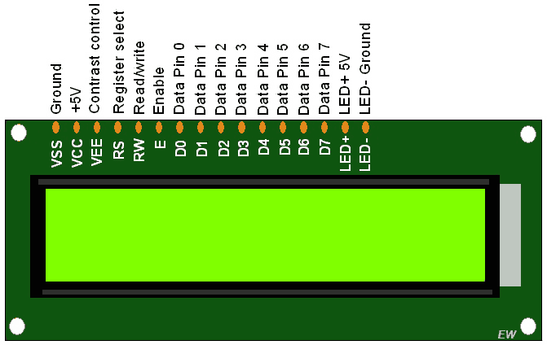

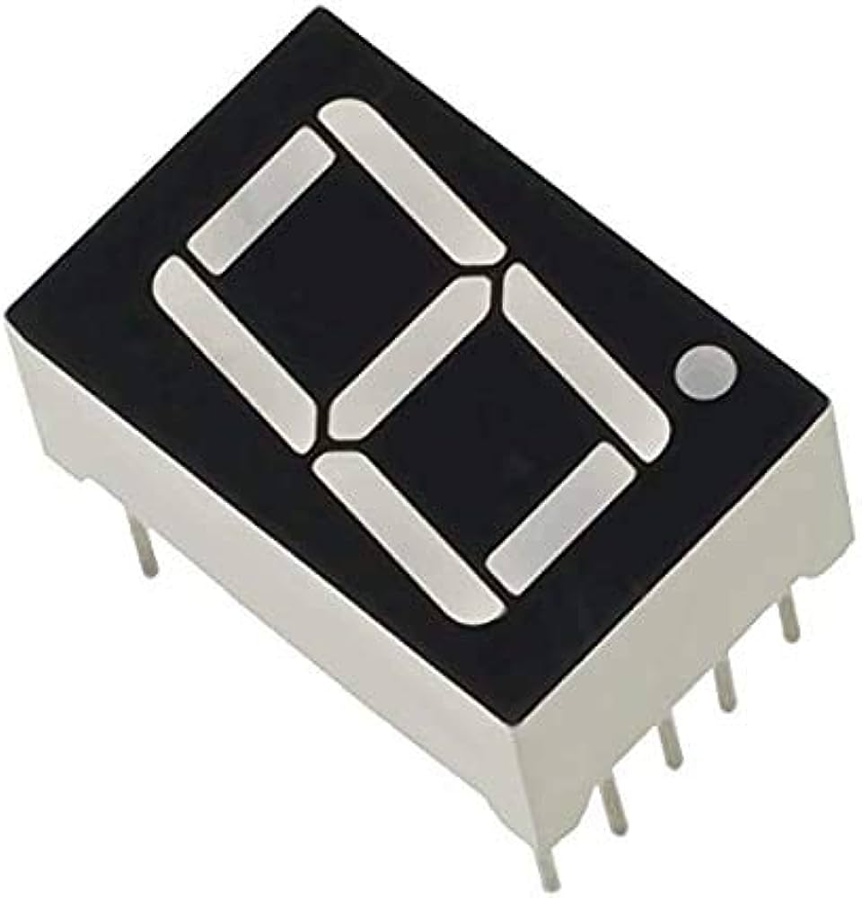

- Code: -
- LCD 8-bit mode: -
#include<stdint.h>
#include<stdbool.h>
#include<inc/tm4c123gh6pm.h>
#include<inc/hw_memmap.h>
#include<driverlib/gpio.h>
#include<driverlib/sysctl.h>
#include<string.h>
lcd_cmd(unsigned char);
int main(void)
{
unsigned char ch[]="VISHWANATH";
int i;
SysCtlClockSet(SYSCTL_SYSDIV_5|SYSCTL_XTAL_16MHZ| SYSCTL_OSC_MAIN| SYSCTL_USE_PLL);
SysCtlPeripheralEnable(SYSCTL_PERIPH_GPIOB);
SysCtlPeripheralEnable(SYSCTL_PERIPH_GPIOA);
GPIOPinTypeGPIOOutput(GPIO_PORTB_BASE, GPIO_PIN_0| GPIO_PIN_1| GPIO_PIN_2 | GPIO_PIN_3|GPIO_PIN_4|GPIO_PIN_5|GPIO_PIN_6|GPIO_PIN_7);
GPIOPinTypeGPIOOutput(GPIO_PORTA_BASE,GPIO_PIN_5|GPIO_PIN_6);
lcd_cmd(0x38);

lcd_cmd(0x0E);
lcd_cmd(0x06);
lcd_cmd(0x01);
while(1){
lcd_cmd(0x80);

for(i=0;i<=10;i++){
lcd_data(ch[i]);
SysCtlDelay(13333333);

}
lcd_cmd(0x01);

}
}
lcd_cmd(unsigned char f){
GPIOPinWrite(GPIO_PORTA_BASE,GPIO_PIN_5,0x00);
GPIOPinWrite(GPIO_PORTA_BASE,GPIO_PIN_6,0X40);
GPIOPinWrite(GPIO_PORTB_BASE, GPIO_PIN_0| GPIO_PIN_1| GPIO_PIN_2 | GPIO_PIN_3|GPIO_PIN_4|GPIO_PIN_5|GPIO_PIN_6|GPIO_PIN_7,f);
SysCtlDelay(13333333);
GPIOPinWrite(GPIO_PORTA_BASE,GPIO_PIN_6,0X00);
SysCtlDelay(13333333);

}

lcd_data(unsigned char a){
GPIOPinWrite(GPIO_PORTB_BASE, GPIO_PIN_0| GPIO_PIN_1| GPIO_PIN_2 | GPIO_PIN_3|GPIO_PIN_4|GPIO_PIN_5|GPIO_PIN_6|GPIO_PIN_7,a);

GPIOPinWrite(GPIO_PORTA_BASE,GPIO_PIN_5,0x20);
GPIOPinWrite(GPIO_PORTA_BASE,GPIO_PIN_6,0X40);
SysCtlDelay(13333333);
GPIOPinWrite(GPIO_PORTA_BASE,GPIO_PIN_6,0X00);
SysCtlDelay(13333333);
}
- LCD 4-bit mode: -
#include<stdint.h>
#include<stdbool.h>
#include<inc/tm4c123gh6pm.h>
#include<inc/hw_memmap.h>
#include<driverlib/gpio.h>
#include<driverlib/sysctl.h>
#include<string.h>
//unsigned char b,c,d,e;
lcd_cmd(unsigned char);
int main(void)
{
unsigned char ch[]="VISHWANATH";
int i;
SysCtlClockSet(SYSCTL_SYSDIV_5|SYSCTL_XTAL_16MHZ|SYSCTL_OSC_MAIN|SYSCTL_USE_PLL);
SysCtlPeripheralEnable(SYSCTL_PERIPH_GPIOB);// TO SEND DATA
SysCtlPeripheralEnable(SYSCTL_PERIPH_GPIOA);// FOR EN AND RS
GPIOPinTypeGPIOOutput(GPIO_PORTB_BASE,GPIO_PIN_4|GPIO_PIN_5|GPIO_PIN_6|GPIO_PIN_7);
GPIOPinTypeGPIOOutput(GPIO_PORTA_BASE,GPIO_PIN_5|GPIO_PIN_6);
lcd_cmd(0x28);
lcd_cmd(0x0E);
lcd_cmd(0x06);
lcd_cmd(0x01);
while(1){
lcd_cmd(0xC0);
for(i=0;i<=10;i++){
lcd_data(ch[i]);
SysCtlDelay(13333333);
}
lcd_cmd(0x01);

}
}

lcd_cmd(unsigned char f){
// b=f & 0xF0;
// c=(f << 4) & 0xF0;
GPIOPinWrite(GPIO_PORTA_BASE,GPIO_PIN_5,0x00);//RS pin
GPIOPinWrite(GPIO_PORTA_BASE,GPIO_PIN_6,0X40);// Enable pin
GPIOPinWrite(GPIO_PORTB_BASE, 0XF0,f&0xF0);
SysCtlDelay(13333333);
GPIOPinWrite(GPIO_PORTA_BASE,GPIO_PIN_6,0X00);// Enable pin
SysCtlDelay(13333333);

GPIOPinWrite(GPIO_PORTB_BASE, 0XF0,(f<<4)&0xF0);
GPIOPinWrite(GPIO_PORTA_BASE,GPIO_PIN_6,0X40);// Enable pin
// GPIOPinWrite(GPIO_PORTA_BASE,GPIO_PIN_5,0x00);//RS pin
SysCtlDelay(13333333);
GPIOPinWrite(GPIO_PORTA_BASE,GPIO_PIN_6,0X00);// Enable pin
}

lcd_data(unsigned char a){
// d=a & 0xF0;
// e=(a << 4) & 0xF0;
GPIOPinWrite(GPIO_PORTA_BASE,GPIO_PIN_5,0x20);//RS pin
GPIOPinWrite(GPIO_PORTA_BASE,GPIO_PIN_6,0X40);// Enable pin
GPIOPinWrite(GPIO_PORTB_BASE, 0XF0,a&0xF0);
SysCtlDelay(13333333);
GPIOPinWrite(GPIO_PORTA_BASE,GPIO_PIN_6,0X00);// Enable pin
SysCtlDelay(13333333);

GPIOPinWrite(GPIO_PORTB_BASE, 0XF0,(a<<4)&0xF0);
GPIOPinWrite(GPIO_PORTA_BASE,GPIO_PIN_6,0X40);// Enable pin
// GPIOPinWrite(GPIO_PORTA_BASE,GPIO_PIN_5,0x20);//RS pin
SysCtlDelay(13333333);
GPIOPinWrite(GPIO_PORTA_BASE,GPIO_PIN_6,0X00);// Enable pin
}

- Seven Segment Display: -
#include<stdint.h>
#include<stdbool.h>
#include<inc/tm4c123gh6pm.h>
#include<inc/hw_memmap.h>
#include<driverlib/gpio.h>
#include<driverlib/sysctl.h>

int main(void)
{
unsigned int a[10]={0x9E,0x25,0x0E,0x99,0x49,0x41,0x1F,0x01,0x09};
unsigned int i;
SysCtlClockSet(SYSCTL_SYSDIV_5|SYSCTL_XTAL_16MHZ|SYSCTL_OSC_MAIN|SYSCTL_USE_PLL);
SysCtlPeripheralEnable(SYSCTL_PERIPH_GPIOB);
SysCtlPeripheralEnable(SYSCTL_PERIPH_GPIOA);
GPIOPinTypeGPIOOutput(GPIO_PORTA_BASE,GPIO_PIN_4);
GPIOPinTypeGPIOOutput(GPIO_PORTB_BASE,GPIO_PIN_0|GPIO_PIN_1|GPIO_PIN_2|GPIO_PIN_3|GPIO_PIN_4|GPIO_PIN_5|GPIO_PIN_6|GPIO_PIN_7);
while(1){
for(i=0;i<10;i++){
GPIOPinWrite(GPIO_PORTB_BASE,GPIO_PIN_0|GPIO_PIN_1|GPIO_PIN_2|GPIO_PIN_3|GPIO_PIN_4|GPIO_PIN_5|GPIO_PIN_6|GPIO_PIN_7,a[i]);
SysCtlDelay(13333333);
}
}
}

